Under Budget

Cameron Rutledge

Personas

James

Background:

* College Graduate
* Graphic Designer

Demographics:

* 24-Year-Old Male
* $45,000 Salary
* Lives Alone

Sarah

Background:

* Electrician’s Apprentice
* Saving Money To Move Out

Demographics:

* 21-Year-Old Female
* $51,000 Salary
* Shares Apartment With 2 Roommates

Don

Background:

* Married
* Travels Bi-Annually

Demographics:

* 68-Year-Old Male
* Retired Teacher
* $12,000 Pension

Wireframes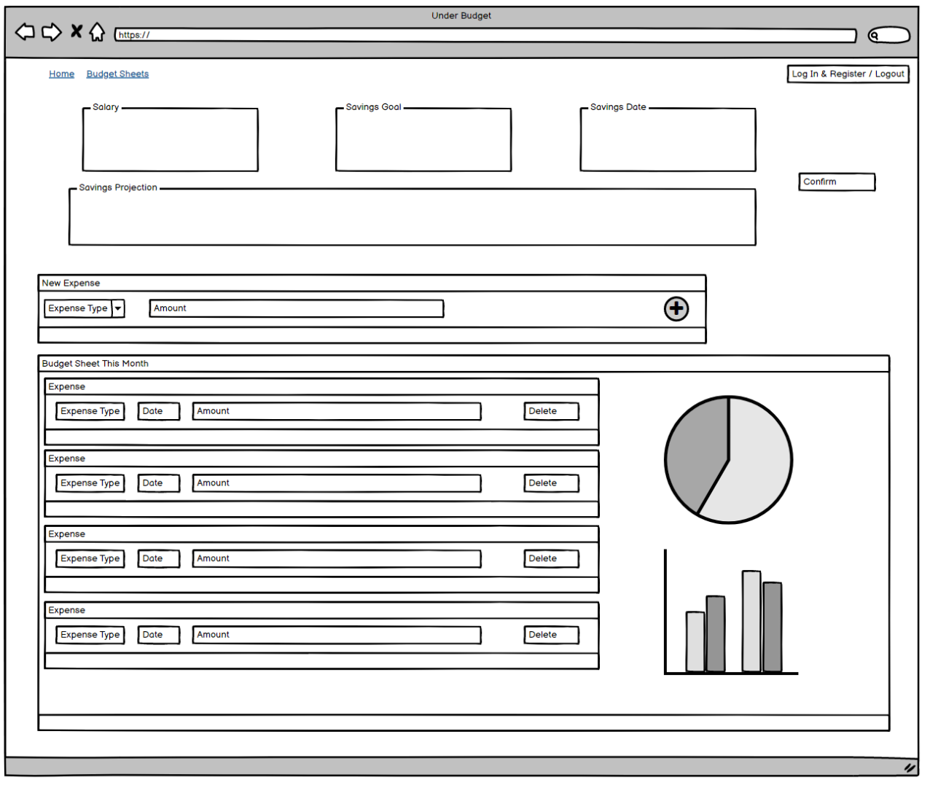

Storyboards

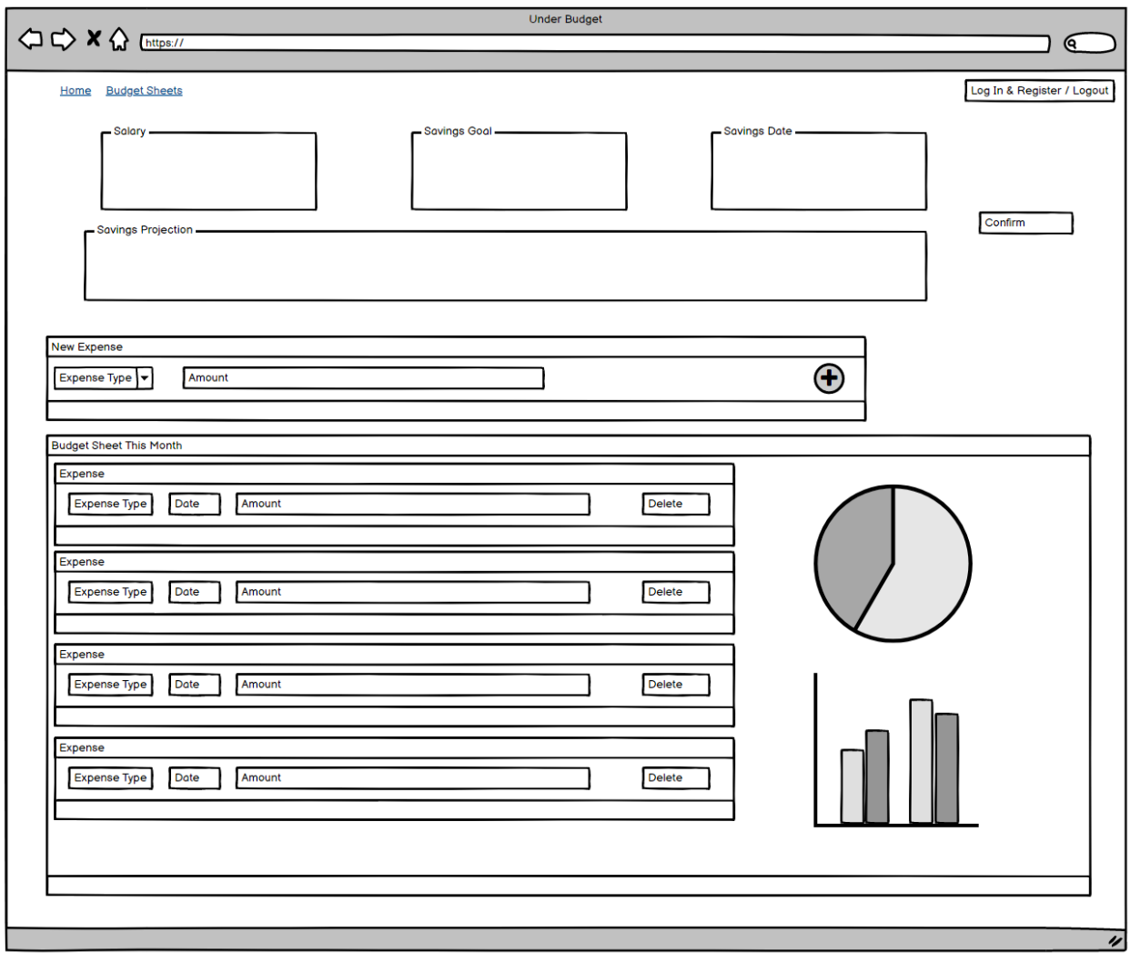

Load Webpage

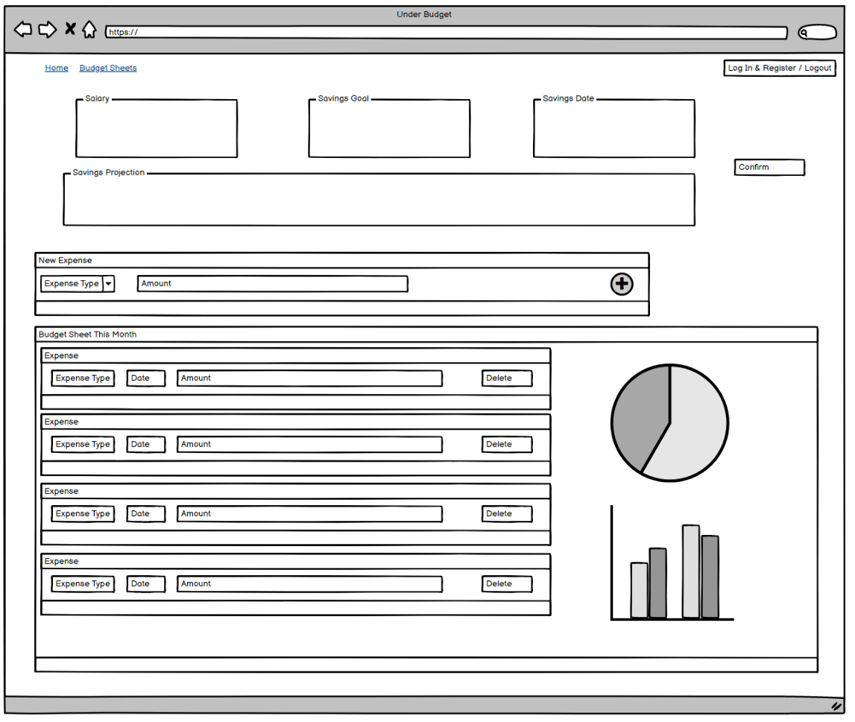

Enter Salary, Savings Goal, and Savings Date to produce output of Savings Projection of how much you need to save per month to reach your savings goal.

Select from a drop-down menu the type of expense and enter the amount of the expense

+ button to submit the new expense entry to the database

Select Confirm to save the data to the user’s account.

Breaks down the expense sheet into easily digestible information of spending habits

Displays the information input above, allows a user to update/remove entries that were submitted

Load Page

Select the Month Selector to change the data displayed in the budget sheet

Hit “Create Account” to attempt account creation, success loads the login page failure reloads the page.

Enter information for account creation.

Enter information for account sign in

Hit “Sign In” to attempt login, success loads the home page failure reloads the page.

Stylesheet

My stylesheet will be utilizing bootstrap with minor changes made for a personal touch to my website design.

Stretch

My stretch goal will be to implement extra expense tracking over the entire savings period, tracking how much money has been saved by the user and adjusting the amount they would need to save per month if they are not meeting their goals.